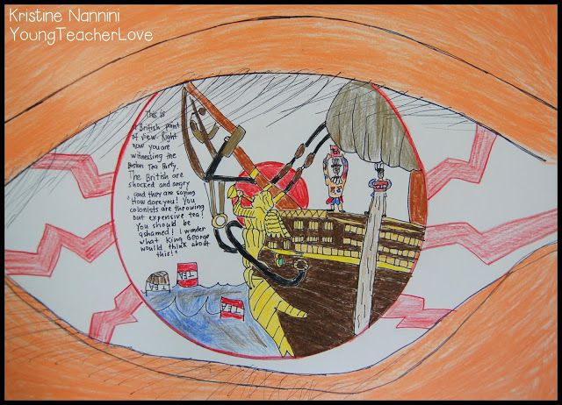
Directions:
Part 1:
Create the point of view of a person living in Linfin, the most polluted city in China.
Include in their vision pictures and symbols to represent the causes, contributions (things adding to the problem), and consequences of pollution in the city. Include at least three different things (use the brainstorm list we came up with as a class to help you).
Remember, you aren’t being graded on your artistic skills but what they represent. Please still take pride in your work by showing details and if time allows, adding color.
Part 2:
Write an explanation of your drawing. Use the following questions as your guide to have a complete answer. Your explanation should be at least a paragraph, 4-5 sentences.
- Whose point of view is it and where are they?
- What are they seeing? Explain the symbols and pictures and what they represent.
- What would the person be feeling or thinking about what they see? What would the person be saying in response to what they see?

